Chanakya University
Student Performance Prediction using
K-Nearest Neighbors Algorithm(KNN)
Shubha.k MCA(25PG00225)

ABSTRACT
In today’s data-driven world, machine learning plays a key role in solving real-world problems. This paper presents a simple and effective approach to predicting student performance using the K-Nearest Neighbors (KNN) algorithm. The model uses students’ academic scores to classify whether they are likely to pass or fail. By analyzing patterns in student data, the system helps in identifying students who may need additional support. The results show that KNN can be effectively used for classification problems in the field of education.

KEYWORDS
Machine Learning, KNN, Student Performance, Classification, Data Analysis

1. INTRODUCTION
Education systems generate a large amount of student-related data, but much of this data is not fully utilized. Machine learning provides an opportunity to analyze this data and extract meaningful insights. Predicting student performance is important because it helps institutions identify students who may struggle academically.
In this project, the K-Nearest Neighbors (KNN) algorithm is used to predict whether a student will pass or fail based on academic scores. The goal is to build a simple model that can assist educators in making better decisions and improving student outcomes.
In recent years, the use of data analytics and machine learning in education has gained significant attention. Educational institutions are increasingly adopting data-driven approaches to improve student performance and reduce dropout rates. Traditional methods of evaluating student performance are often limited and do not provide early insights into potential academic risks.

Machine learning techniques enable the analysis of large volumes of student data to identify patterns and trends. By using predictive models, institutions can proactively support students who may face difficulties. This not only improves academic outcomes but also enhances overall educational quality.

2. LITERATURE REVIEW
The selected research paper focuses on predicting student dropout using machine learning techniques. It studies various factors such as academic performance, attendance, and student background to understand patterns that affect student success.
The paper applies different machine learning algorithms to classify students based on their likelihood of continuing their education. It highlights the importance of early prediction so that institutions can provide timely support. This project builds upon the same idea by applying the KNN algorithm to classify student performance.

3. METHODOLOGY
The proposed system uses the K-Nearest Neighbors (KNN) algorithm, which is a supervised machine learning technique used for classification problems. The main idea behind KNN is to classify a data point based on the similarity between it and other data points in the dataset. This similarity is measured using distance metrics.
In this study, academic scores such as math, reading, and writing are used as input features to predict student performance. A new feature called the average score is calculated by taking the mean of these subject scores. Based on this average, students are classified into two categories: pass and fail. This transformation helps convert the problem into a binary classification task.
Before applying the model, the dataset undergoes preprocessing. Categorical variables are converted into numerical form using encoding techniques, which allows the machine learning model to process the data effectively. The dataset is then divided into training and testing sets, where the training set is used to build the model and the testing set is used to evaluate its performance.
The KNN algorithm works by calculating the distance between a new data point and all the points in the training dataset. The most commonly used distance metric is Euclidean distance, which is given by:
d(x,y) = √(Σ (xi − yi)²)
The value of k represents the number of nearest neighbors considered for classification. In this project, k is selected as 5, which provides a balance between bias and variance. A smaller value of k may lead to overfitting, while a larger value may reduce the model’s sensitivity to patterns.
Once the nearest neighbors are identified, the algorithm uses majority voting to assign the class label. The class that appears most frequently among the neighbors is assigned to the new data point. This makes KNN a simple yet powerful algorithm for classification tasks.
Overall, the methodology focuses on transforming raw student data into meaningful features, applying the KNN algorithm, and evaluating its performance to ensure accurate prediction of student outcomes.

4. IMPLEMENTATION
The implementation of the proposed system is carried out using Python in the Google Colab environment. This platform provides a convenient interface for executing machine learning models without requiring complex setup. Various libraries such as pandas, numpy, and scikit-learn are used for data handling, preprocessing, and model development.
Initially, the dataset is loaded into the environment using the pandas library. The dataset contains student performance data, including scores in math, reading, and writing. To make the data suitable for machine learning, preprocessing steps are performed. A new feature called the average score is calculated by taking the mean of the subject scores. Based on this value, a target variable is created to classify students into pass or fail categories.
After preprocessing, categorical variables are converted into numerical format using encoding techniques. This step is essential because machine learning algorithms require numerical input. The dataset is then divided into input features and target variables. The features represent student scores, while the target represents the classification outcome.
The dataset is further split into training and testing sets using the train-test split method. Typically, 80% of the data is used for training the model, and the remaining 20% is used for testing. This ensures that the model is evaluated on unseen data, providing a realistic measure of its performance.
The K-Nearest Neighbors (KNN) algorithm is then applied using the scikit-learn library. The model is initialized with a chosen value of k, which represents the number of nearest neighbors considered during classification. In this project, k is set to 5. The model is trained using the training dataset and learns patterns based on the similarity between data points.
Once the model is trained, it is used to make predictions on the test dataset. The performance of the model is evaluated using accuracy as the primary metric. Additionally, a sample prediction is performed to demonstrate how the model classifies new data points.
To better understand the results, visualization techniques are used. A scatter plot is generated to show the relationship between different subject scores, highlighting the separation between pass and fail categories. These visualizations help in interpreting the model’s behavior and validating its predictions.

5. RESULTS AND ANALYSIS
The performance of the proposed K-Nearest Neighbors (KNN) model was evaluated using accuracy as the primary metric. After training the model on the training dataset and testing it on unseen data, the model achieved an accuracy of 99%, which indicates that the model performs well in classifying student performance.
The results clearly show that academic scores play a significant role in determining student outcomes. Students with higher scores in subjects such as math, reading, and writing are more likely to pass, while those with lower scores tend to fall into the fail category. This demonstrates that the model is able to capture meaningful patterns in the dataset.
To further analyze the results, visualization techniques are used. A scatter plot is generated to illustrate the relationship between subject scores. The graph shows a clear trend where students with higher scores in one subject often perform well in others. Additionally, the use of color coding for pass and fail categories helps in visually distinguishing the classification boundaries.

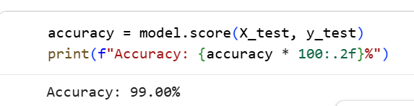
Fig 1: Relationship between student scores and pass/fail classification

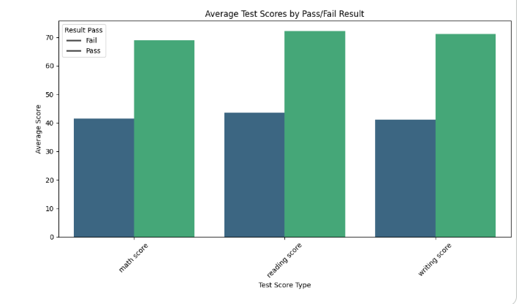
Fig 2: Comparison of average math, reading, and writing scores between pass and fail student groups
The scatter plot highlights that there is a positive correlation between different subject scores. Students who perform well in math tend to perform well in reading and writing as well. This consistency across subjects supports the effectiveness of using these features for prediction.
In addition to the scatter plot, a heatmap is used to analyze the relationships between different features in the dataset. The heatmap provides a visual representation of the correlation matrix, where stronger correlations are represented by more intense colors.
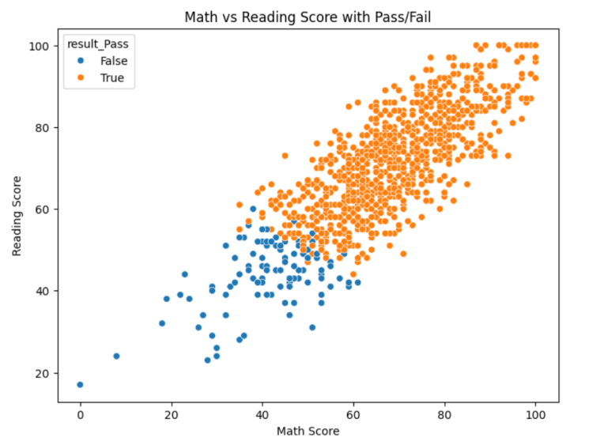
Fig 3: Scatter plot showing the relationship between math and reading scores with pass/fail classification

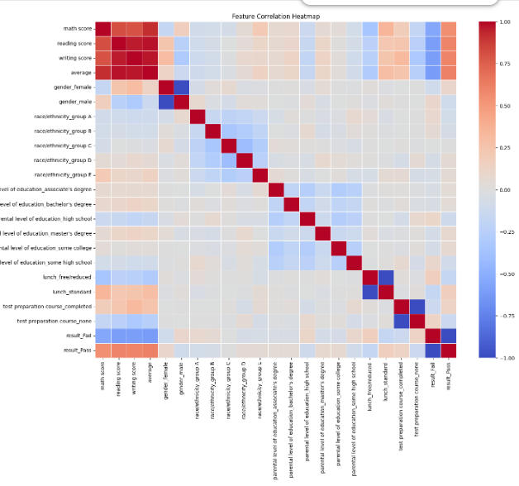

Fig 4: Correlation heatmap showing relationships between different features in the dataset
The heatmap shows that there is a strong positive relationship between the subject scores and the average score. This indicates that the selected features are highly relevant for predicting student performance. Such correlations help improve the accuracy of the KNN model, as the algorithm relies on similarity between data points.
Overall, the results demonstrate that the KNN algorithm is effective in classifying student performance based on academic data. The combination of numerical evaluation and visualization provides a clear understanding of the model’s behavior and supports its practical application in educational systems.

6. CONCLUSION
This project demonstrates the practical use of the K-Nearest Neighbors (KNN) algorithm in predicting student performance. The model successfully classifies students into pass and fail categories and provides useful insights into their academic behavior.
The results highlight that simple machine learning techniques can be effectively used in education to improve decision-making. In the future, the model can be improved by using larger datasets and more advanced algorithms to achieve higher accuracy.
This study shows that even simple algorithms like KNN can provide valuable insights when applied correctly. With further improvements and real-world data, such systems can be integrated into educational platforms.

7. DISCUSSION
The results obtained from the K-Nearest Neighbors (KNN) model demonstrate that student performance can be effectively predicted using academic scores. The model performs well in identifying patterns within the dataset, especially when the features are strongly related, such as math, reading, and writing scores. The use of average score as an additional feature further improves the model’s ability to classify students accurately.
One of the key observations from this study is that students tend to perform consistently across subjects. This is supported by both the scatter plot and the heatmap, which show a positive correlation between different subject scores. Such relationships make KNN a suitable algorithm, as it relies on similarity between data points to make predictions.
However, the performance of the KNN algorithm depends on several factors. The choice of the parameter k plays a crucial role in determining accuracy. A smaller value of k may lead to overfitting, where the model becomes too sensitive to noise in the data. On the other hand, a larger value of k may oversimplify the model and reduce its ability to capture important patterns.
Another limitation of KNN is its computational cost. Since the algorithm calculates the distance between a new data point and all existing data points, it can become slow when applied to large datasets. This makes it less suitable for real-time applications involving large-scale data.
Despite these limitations, KNN remains a simple and effective algorithm for classification tasks, especially when the dataset is relatively small and well-structured. The results of this study highlight that even basic machine learning techniques can provide valuable insights when applied correctly.
Overall, the discussion shows that the model is reliable, but its performance can be further improved by optimizing parameters, selecting better features, and using larger datasets in future work.
8. REFERENCES
[1] Abhishek Sharma, Ritu Chauhan, “Student Dropout Prediction Using Machine Learning Techniques,” SSRN.
[2] Scikit-learn Documentation, https://scikit-learn.org/
[3] Student Performance Dataset, Kaggle.
[4] UCI Machine Learning Repository.
[5] A. Sharma and R. Chauhan, “Student Dropout Prediction Using Machine Learning Techniques,” SSRN, 2020.
[6] F. Marbouti, H. A. Diefes-Dux, and K. Madhavan, “Models for early prediction of at-risk students in a course using standards-based grading,” Computers & Education, 2016.
[7] A. Yadav and D. Pal, “Data Mining: A Prediction for Performance Improvement of Engineering Students using Classification,” World of Computer Science and Information Technology Journal, 2012.
[8] K. Shahiri, W. Husain, and N. A. Rashid, “A Review on Predicting Student’s Performance using Data Mining Techniques,” Procedia Computer Science, 2015.
[9] E. Osmanbegović and M. Suljić, “Data Mining Approach for Predicting Student Performance,” Economic Review, 2012.
[10] C. Romero and S. Ventura, “Educational Data Mining: A Review of the State of the Art,” IEEE Transactions on Systems, Man, and Cybernetics, 2010.
[11] T. M. Mitchell, *Machine Learning*, McGraw-Hill, 1997.
[12] I. H. Witten, E. Frank, and M. A. Hall, *Data Mining: Practical Machine Learning Tools and Techniques*, Morgan Kaufmann, 2011.
[13] Scikit-learn Documentation, https://scikit-learn.org/
[14] Student Performance Dataset, Kaggle, https://www.kaggle.com/
[15] UCI Machine Learning Repository, https://archive.ics.uci.edu/
[16] J. Han, M. Kamber, and J. Pei, *Data Mining: Concepts and Techniques*, Elsevier, 2012.

